**MRF – Array Method**

MRF – Moving Reference Frame

1. Join ()
2. Sort ()
3. Reverse ()
4. Push ()
5. Pop ()
6. Shift ()
7. Unshift ()
8. Concat ()

1.Join ()

<html>

<body>

<h1>JavaScript Arrays</h1>

<h2>The join() Method</h2>

<p>join() returns an array as a string:</p>

<p id="demo"></p>

<script>

    const india = [ "Tamilnadu","Karnataka","Kerala","Delhi","Andhra Pradesh"];

    let text = india.join();

    document.getElementById("demo").innerHTML=text;

</script>

</body>

</html>

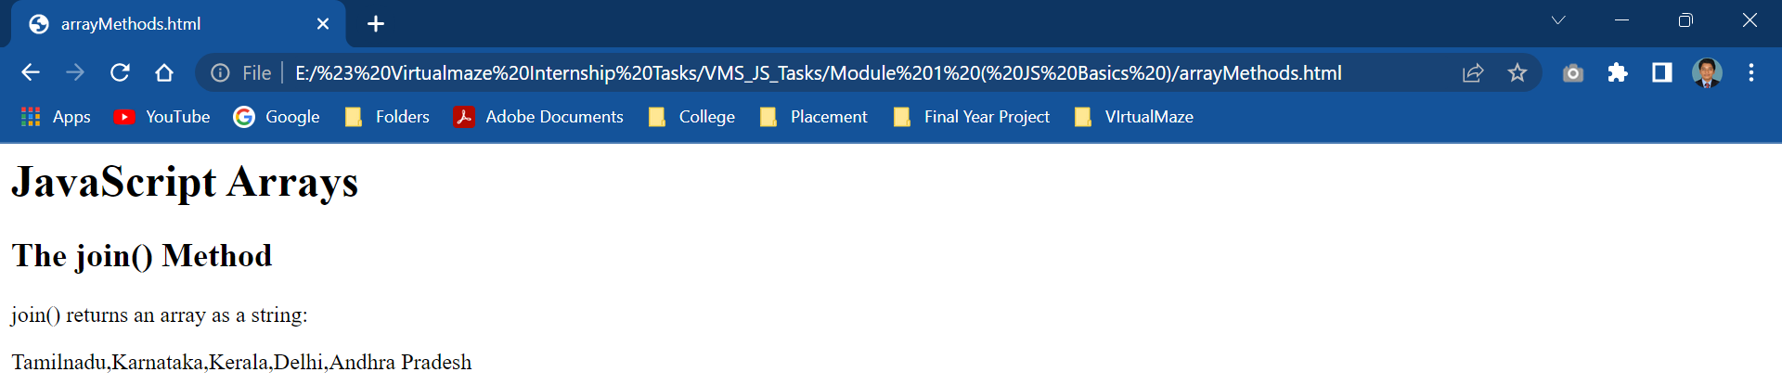

2.Sort ()

<html>

<body>

<h1>JavaScript Arrays</h1>

<h2>The sort() Method</h2>

<p>sorts the elements of an array</p>

<p id="demo"></p>

<script>

    const india = [ "Tamilnadu","Karnataka","Kerala","Delhi","Andhra Pradesh"];

    document.getElementById("demo").innerHTML=india.sort();

</script>

</body>

</html>

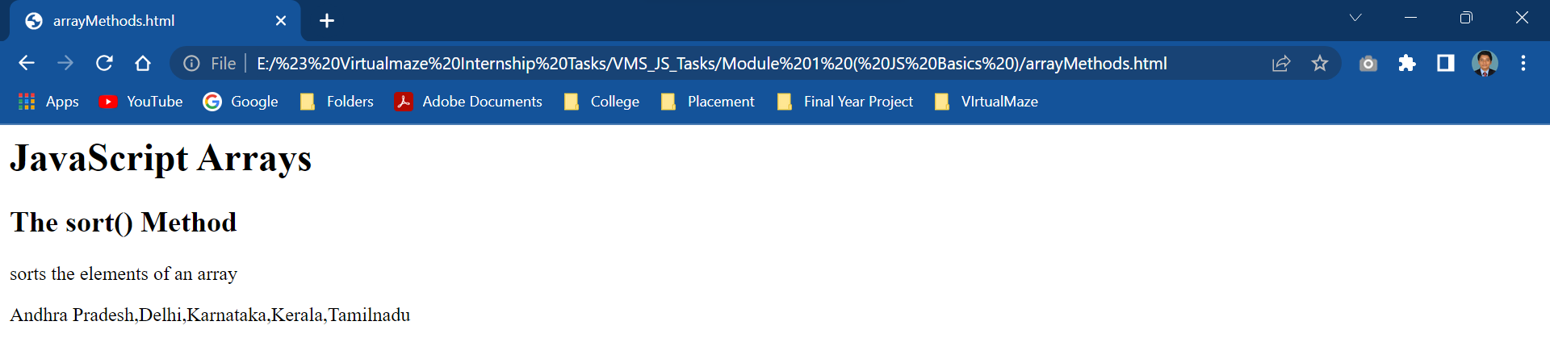

3.Reverse ()

<html>

<body>

<h1>JavaScript Arrays</h1>

<h2>The reverse() Method</h2>

<p>reverse() method reverses the order of the elements in an array</p>

<p id="demo"></p>

<script>

    const india = [ "Tamilnadu","Karnataka","Kerala","Delhi","Andhra Pradesh"];

    document.getElementById("demo").innerHTML=india.reverse();

</script>

</body>

</html>

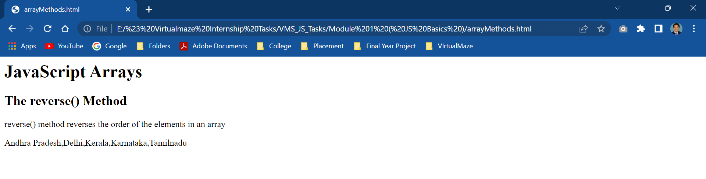

4.Push ()

<html>

<body>

<h1>JavaScript Arrays</h1>

<h2>The push() Method</h2>

<p>push() adds new items to the end of an array</p>

<p id="demo"></p>

<script>

    const india = [ "Tamilnadu","Karnataka","Kerala","Delhi","Andhra Pradesh"];

    india.push("Kolkata");

    document.getElementById("demo").innerHTML=india;

</script>

</body>

</html>

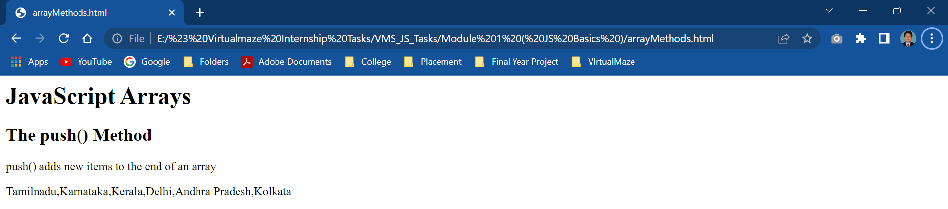

5.Pop ()

<html>

<body>

<h1>JavaScript Arrays</h1>

<h2>The pop() Method</h2>

<p>pop() removes the last element of an array</p>

<p id="demo"></p>

<script>

    const india = [ "Tamilnadu","Karnataka","Kerala","Delhi","Andhra Pradesh"];

    india.pop();

    document.getElementById("demo").innerHTML=india;

</script>

</body>

</html>

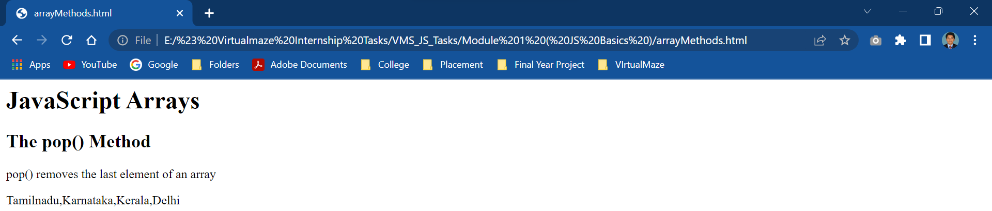

6.Shift ()

<html>

<body>

<h1>JavaScript Arrays</h1>

<h2>The shift() Method</h2>

<p>shift() removes the first item of an array</p>

<p id="demo"></p>

<script>

    const india = [ "Tamilnadu","Karnataka","Kerala","Delhi","Andhra Pradesh"];

    document.getElementById("demo").innerHTML=india.shift();

</script>

</body>

</html>

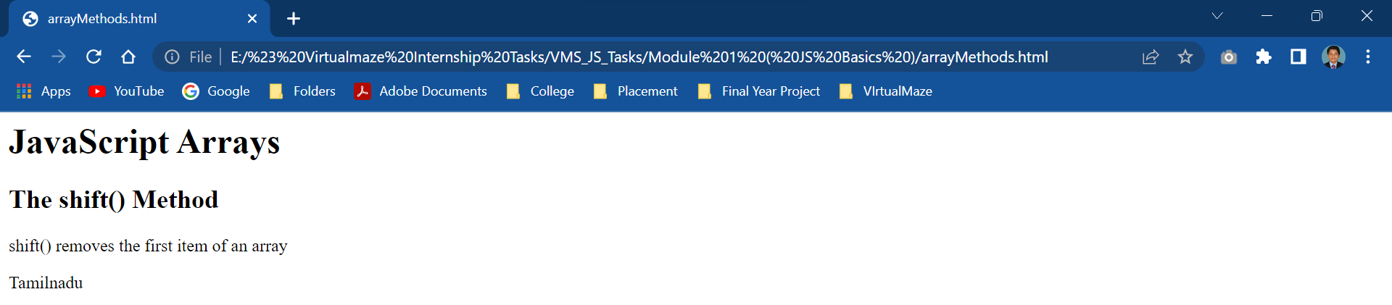

7.Unshift ()

<html>

<body>

<h1>JavaScript Arrays</h1>

<h2>The unshift() Method</h2>

<p>unshift() adds new items to the beginning of an array</p>

<p id="demo"></p>

<script>

    const india = [ "Tamilnadu","Karnataka","Kerala","Delhi","Andhra Pradesh"];

    india.unshift("Madhya Pradesh","Maharastra")

    document.getElementById("demo").innerHTML=india;

</script>

</body>

</html>

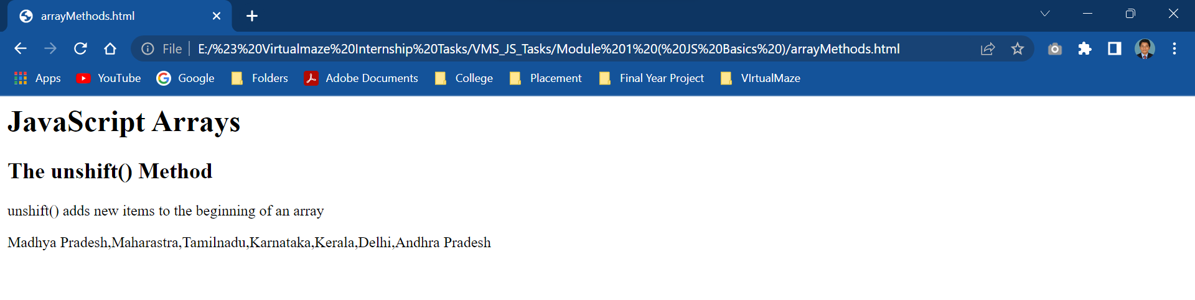

8.Concat ()

<html>

<body>

<h1>JavaScript Arrays</h1>

<h2>The concat() Method</h2>

<p>concat() method concatenates (joins) two or more arrays</p>

<p id="demo"></p>

<script>

    const india = [ "Tamilnadu","Karnataka","Kerala","Delhi","Andhra Pradesh"];

    const america = ["New York","Texas","Washington"];

    const text = india.concat(america);

    document.getElementById("demo").innerHTML=text;

</script>

</body>

</html>

